Lab 03 – Worksheet

Name: M. Shees Abbas | ID: ma11212 | Section:T4

Note: Assumptions and logics should be explained separately in tasks after the task results.

Task 1

Provide appropriately commented codes (Mention question part before each part)
.text
.globl main
main:
addi x10, x0, 12
addi x11, x0, 12
jal x1, sum
addi x11,x10, 0
li x10,1
ecall
j Exit
sum:
add x10, x11,x10
jalr x0,0(x1)

Exit:

end:
j end

Add screenshot of your results (register)
PC before and after procedure call:
PC before and after procedure return:
Terminal output from ecall:
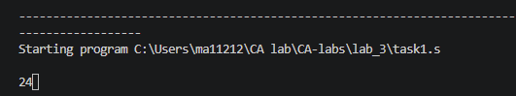
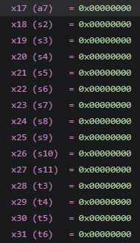
The final values of registers:
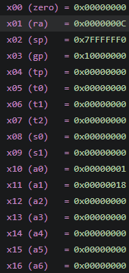

Task 2

Provide appropriately commented codes (Mention question part before each part)
.text
.globl main
main:
li x10, 4
li x11, 3
li x12, 2
li x13, 1

li x18, 10
li x19, 20
li x20, 30

jal x1, leaf
j Exit

leaf:
addi sp, sp, -12
sw x18, 0(sp)
sw x19, 4(sp)
sw x20, 8(sp)
li x20, 0
add x18,x10,x11
add x19,x12,x13
sub x20, x18, x19
mv x10, x20
lw x20, 8(sp)
lw x19, 4(sp)
lw x18, 0(sp)
addi sp, sp, 12
jalr x0, 0(x1)

Exit:

end:
j end

Add screenshot of your results
PC before and after procedure call:
Sp after storing registers in stack and after loading from stack:
Memory values:
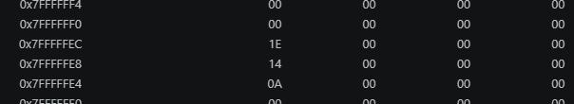
Final register
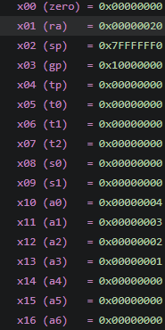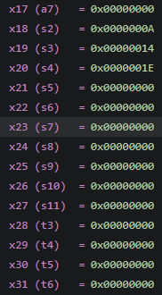

Task 3 Provide appropriately commented codes (Mention question part before each part)
.text
.globl main

main:
li a0, 0x100 # a0 = base address of v
li a1, 0 # a1 = k = 0

# Populate only the two elements the swap uses
li t0, 10
li t1, 20
sw t0, 0(a0) # v[0] = 10
sw t1, 4(a0) # v[1] = 20

jal ra, swap # call swap(v, k)

lw s0, 0(a0) # s0 = v[0], should now be 20
lw s1, 4(a0) # s1 = v[1], should now be 10
j end

swap:
slli t1, a1, 2 # t1 = k * 4 (each long is 4 bytes)
add t1, a0, t1 # t1 = address of v[k]
lw t0, 0(t1) # temp = v[k]
lw t2, 4(t1) # t2 = v[k+1]
sw t2, 0(t1) # v[k] = v[k+1]
sw t0, 4(t1) # v[k+1] = temp
jalr x0, 0(ra) # return to caller

end:
j end

Add screenshots of your results
PC before and after function call
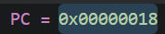
Memory before and after function call
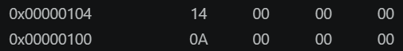

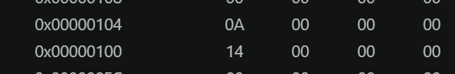
Final register values
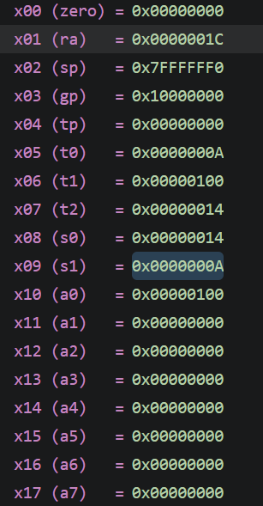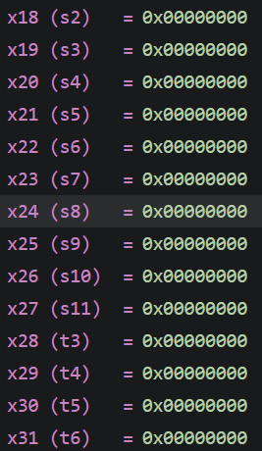

Task 4 Provide appropriately commented codes

.text
.globl main

main:
li a0, 0x200 # a0 = base address of x (destination)
li a1, 0x100 # a1 = base address of y (source)

# Populate y with the string "Hi!" and the null terminator
li t0, 72 # 'H'
li t1, 105 # 'i'
li t2, 33 # '!'
sb t0, 0(a1) # y[0] = 'H'
sb t1, 1(a1) # y[1] = 'i'
sb t2, 2(a1) # y[2] = '!'
sb zero, 3(a1) # y[3] = '\0'

jal ra, strcpy # call strcpy(x, y)

lbu s0, 0(a0) # s0 = x[0], should be 72 ('H')
lbu s1, 1(a0) # s1 = x[1], should be 105 ('i')
lbu s2, 2(a0) # s2 = x[2], should be 33 ('!')
lbu s3, 3(a0) # s3 = x[3], should be 0 ('\0')
j end # done

strcpy:
li t0, 0 # i = 0
loop:
add t1, t0, a1 # t1 = address of y[i]
lbu t2, 0(t1) # t2 = y[i]
add t3, t0, a0 # t3 = address of x[i]
sb t2, 0(t3) # x[i] = y[i]
beq t2, zero, done # if y[i] == '\0', exit loop
addi t0, t0, 1 # i += 1
j loop
done:
jalr x0, 0(ra)

end:
j end

Add screenshots of your results
Memory value before and after function call
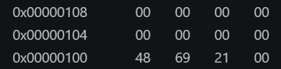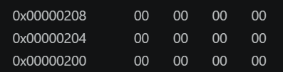
After:
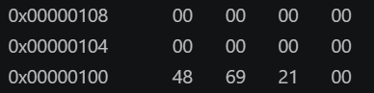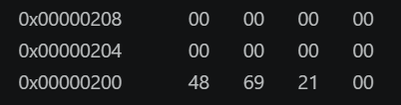
Final register values:
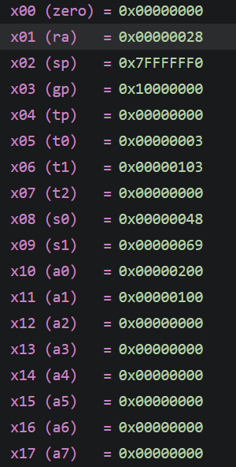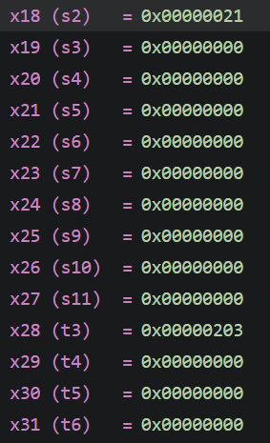

Lab 03 – Introduction to RISC V Assembly (Jumps and Returns)

Assessment Rubrics

Points Distribution
Task No. | LR2  Code | LR5  Results | AR7  Report  Submission and Git Upload
Task 1 | /10 | /05 | /10 & /10
Task 2 | /10 | /10 | /10 & /10
Task 3 | /10 | /10 | /10 & /10
Task 4 | /15 | /10 | /10 & /10
Total Points | /100 Points
CLO Mapped | CLO 2
For description of different levels of the mapped rubrics, please refer the provided Lab Evaluation Assessment Rubrics and Affective Domain Assessment Rubrics.
# | Assessment Elements | Level 1: Unsatisfactory  Points 0-1 | Level 2: Developing  Points 2 | Level 3:Good  Points 3 | Level 4:Exemplary  Points 4
LR2 | Program/Code/ Simulation Model/ Network Model | Program/code/simulation model/network model does not implement the required functionality and has several errors. The student is not able to utilize even the basic tools of the software. | Program/code/simulation model/network model has some errors and does not produce completely accurate results. Student has limited command on the basic tools of the software. | Program/code/simulation model/network model gives correct output but not efficiently implemented or implemented by computationally complex routine. | Program/code/simulation /network model is efficiently implemented and gives correct output. Student has full command on the basic tools of the software.
LR5 | Results & Plots | Figures/ graphs / tables are not developed or are poorly constructed with erroneous results. Titles, captions, units are not mentioned. Data is presented in an obscure manner. | Figures, graphs and tables are drawn but contain errors. Titles, captions, units are not accurate. Data presentation is not too clear. | All figures, graphs, tables are correctly drawn but contain minor errors or some of the details are missing. | Figures / graphs / tables are correctly drawn and appropriate titles/captions and proper units are mentioned. Data presentation is systematic.
AR9 | Report | All the in-lab tasks are not included in report and / or the report is submitted too late. | Most of the tasks are included in report but are not well explained. All the necessary figures / plots are not included. Report is submitted after due date. | Good summary of most the in-lab tasks is included in report. The work is supported by figures and plots with explanations. The report is submitted timely. | Detailed summary of the in-lab tasks is provided. All tasks are included and explained well. Data is presented clearly including all the necessary figures, plots and tables.

Repo github: https://github.com/M-Shees-Abbas/CA-labs.git

